# LAVANYA SANTANA S

# 24MCR059

**DEVOPS TRAINING**

**DAY 3 & 4**

# Step 1:

Create the directory as webapp and make the directory frontend and backend and create a nano products.csv file and check in excel whether the format is correct

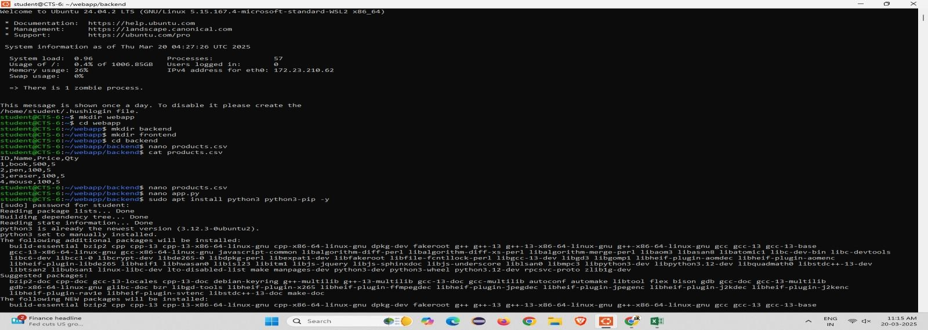

**Step 2:** Install the python3-pandas-y libraries into it

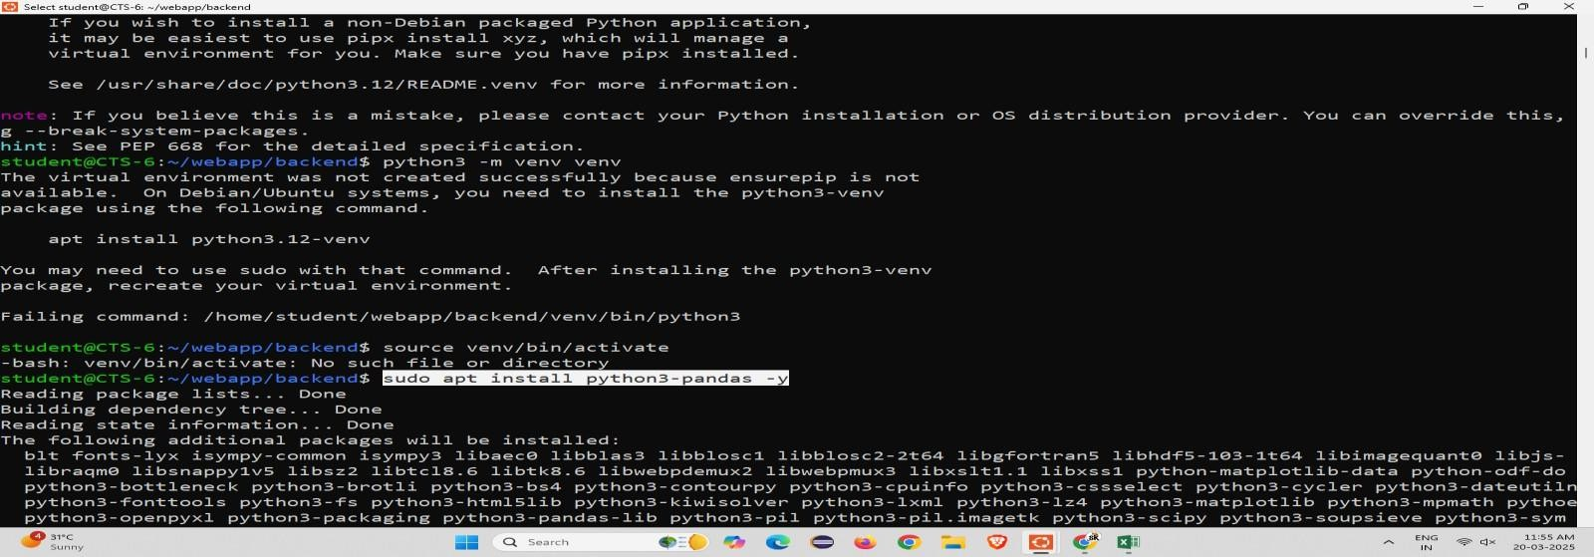

# Step 3:

Using sudo docker images command to view list

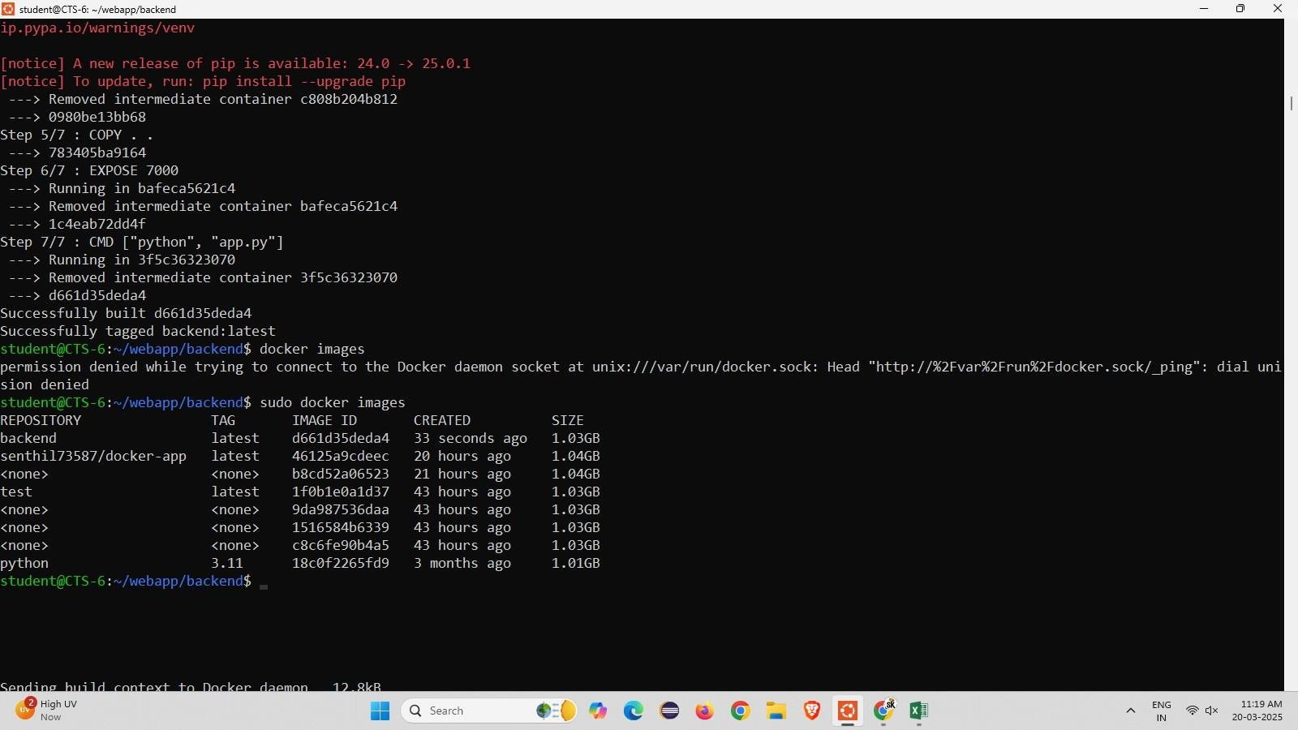

# App.py

from flask import Flask import pandas as pd app = Flask( name )

@app.route("/products", methods=['GET']) # ⬛ Fixed 'methods' issue def read_data():

df = pd.read_csv("products.csv") json_data = df.to_json()

return json_data

if name == " main ": app.run(host="0.0.0.0", port=7000)

# Docker File

FROM python:3.11 WORKDIR /app

COPY requirements.txt . # Ensure pandas is in requirements.txt RUN pip install --no-cache-dir -r requirements.txt

COPY . . EXPOSE 7000

CMD ["python", "app.py"]

# Step 4 :

nano dockerfile and nano docker built –t backend . to built the docker.

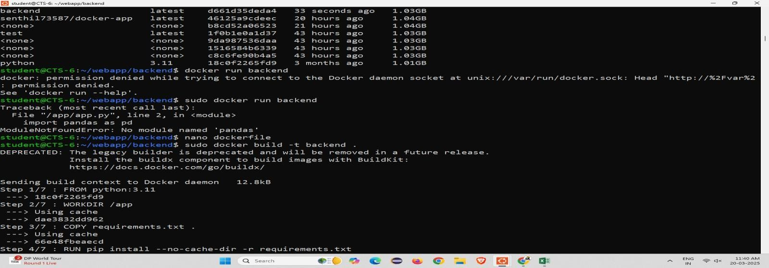

# Step 5 :

using sudo docker run –p 7000:7000 backend command to run the backend

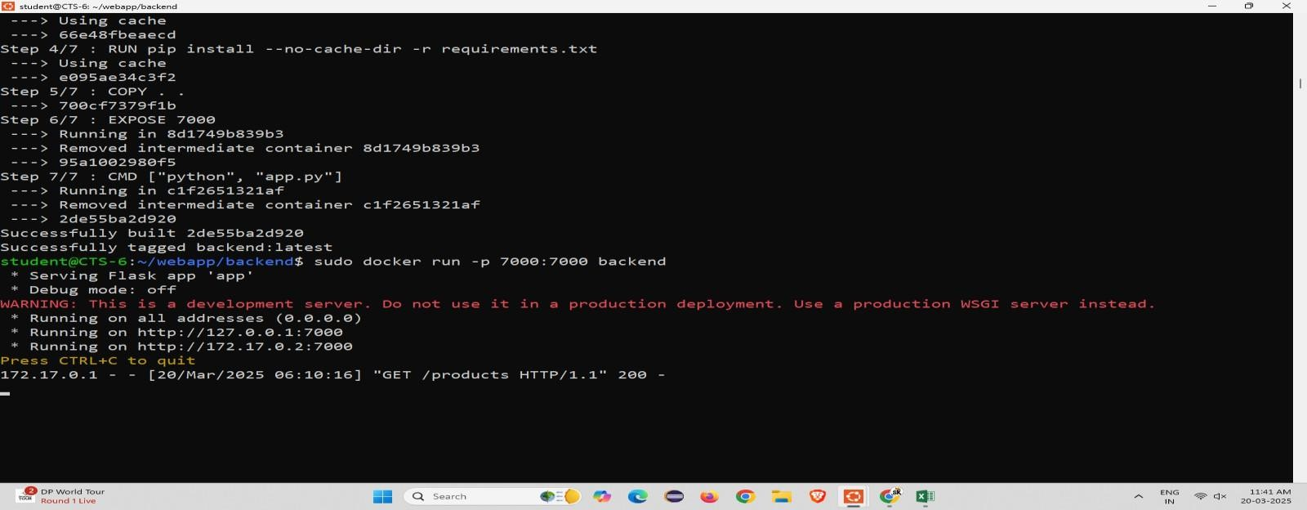

# Step 6:

Open new Ubuntu and run as administration and enter the command as curl –X GET <http://localhost:7000/products>

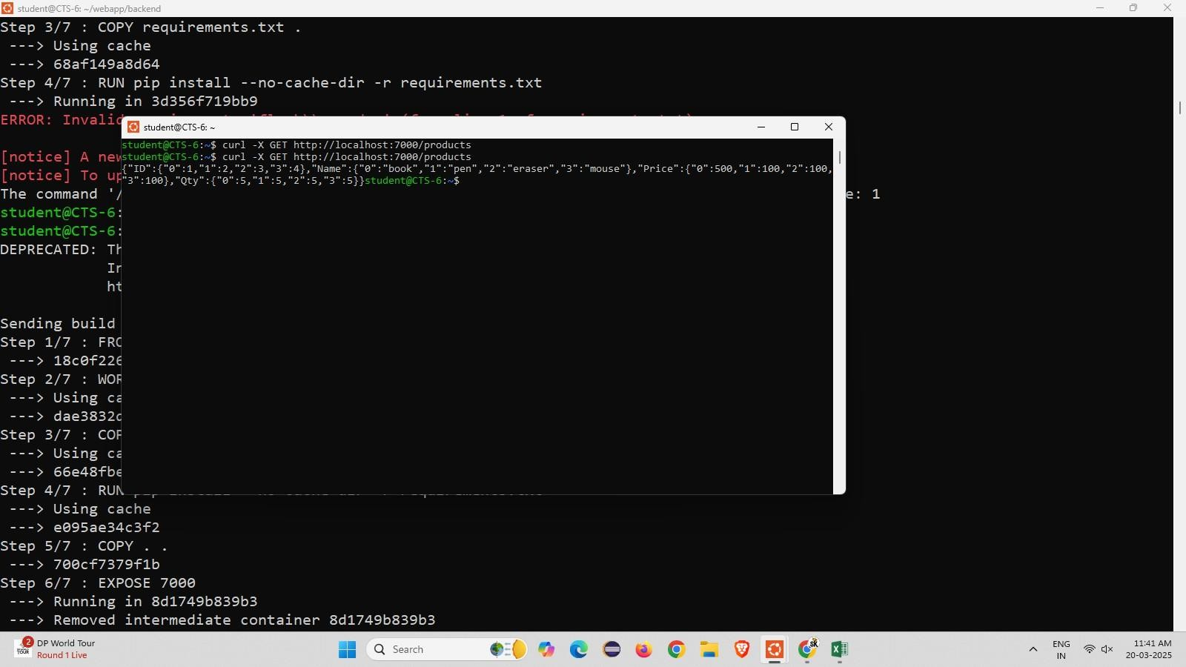

**Step 7:** Go to the browser and enter the url it displays the backend the backend

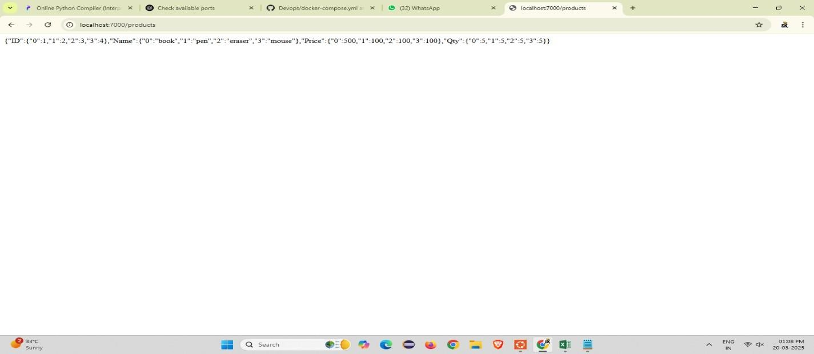

# Step 8:

Change the repository to frontend and create a nano index.html file and enter the code

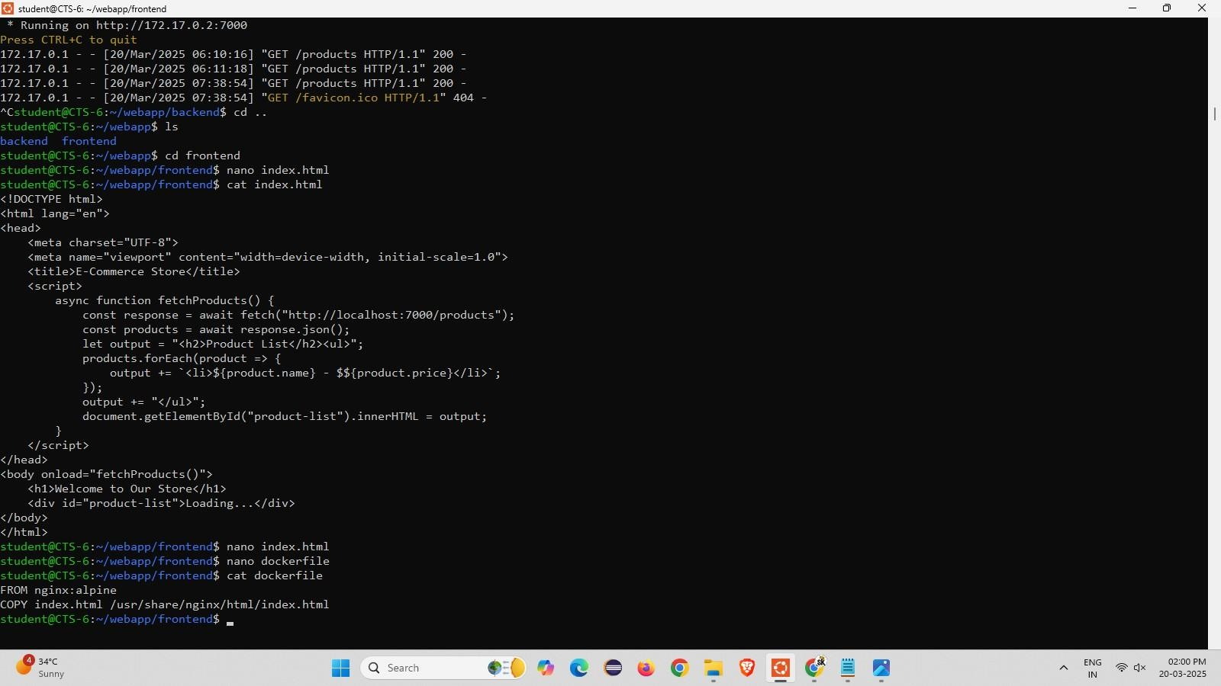

# Step 9:

Change the directory and and make the directory k8s in that create a nano backend-deployment.yaml and add the code

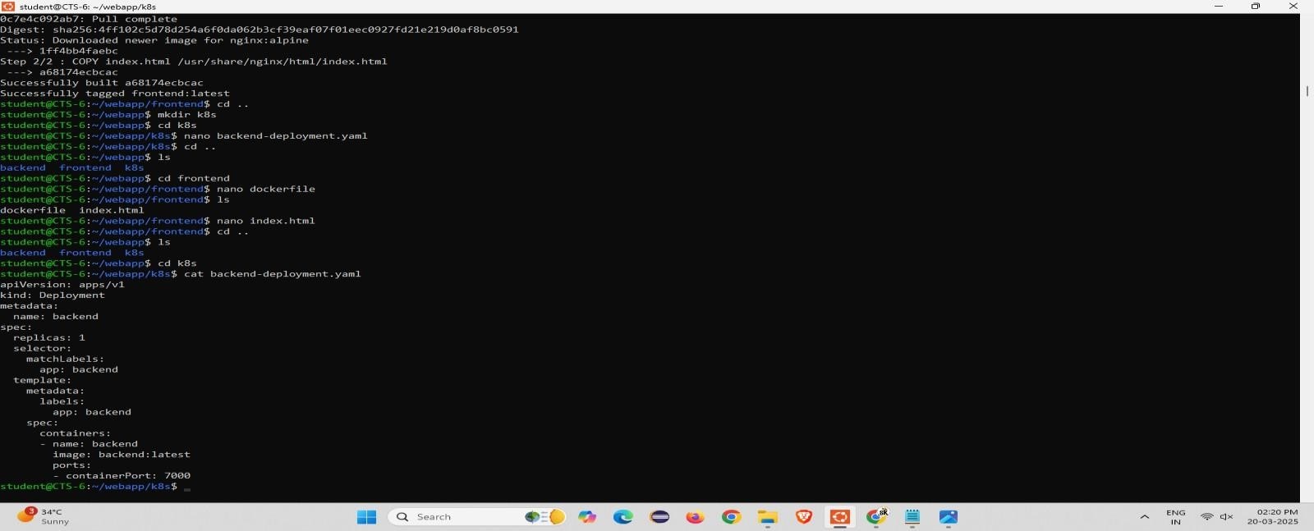

# Step 10:

Create another nano frontend-deployment.yaml file and add the code

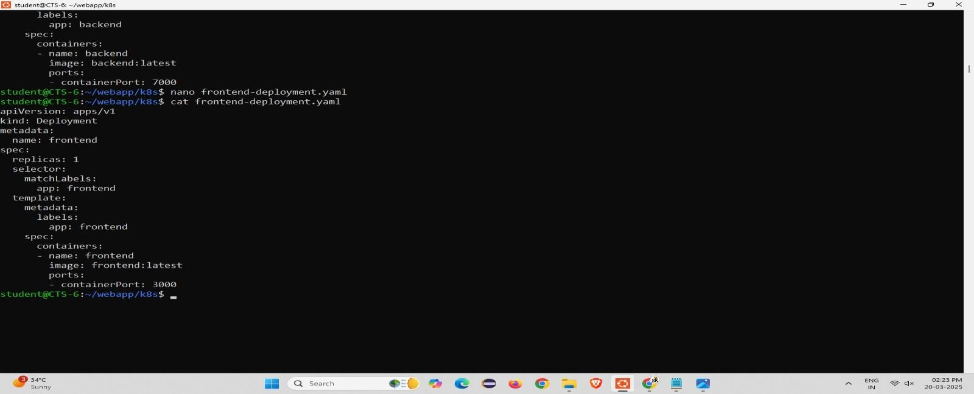

# Step 11:

Create another nano service.yaml and configmap.yaml file and add the code

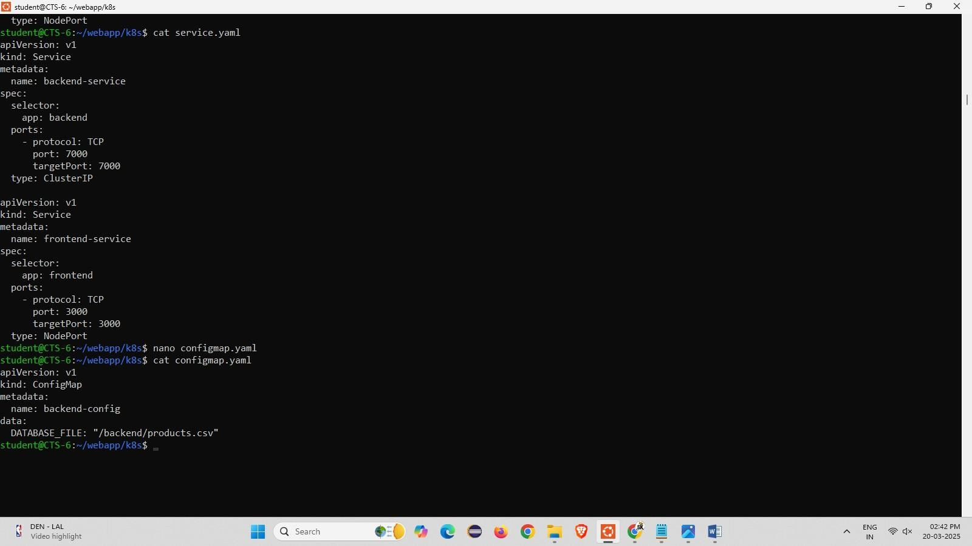

# Step 12:

Clone the kubernetes github repository and run the following commands

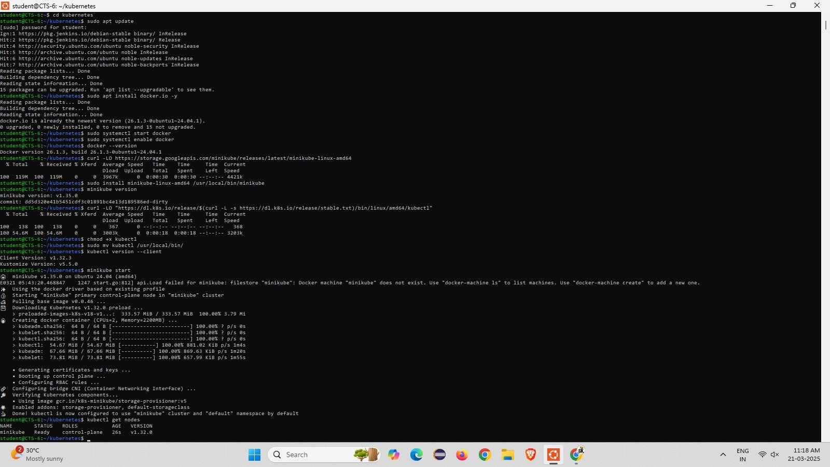

# Step 13 :

Go to the kubernetes backend and frontend directory and type the command to load an image

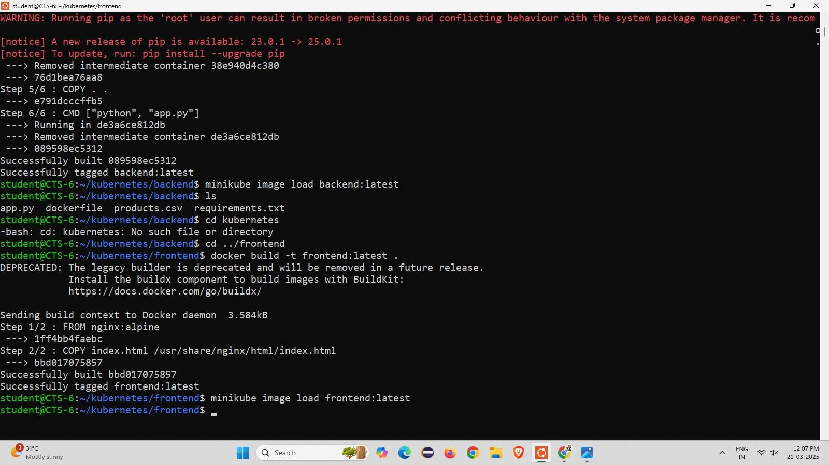

**Step 14 :** Come back to root directory setup minikube docker- env and build the frontend and backend

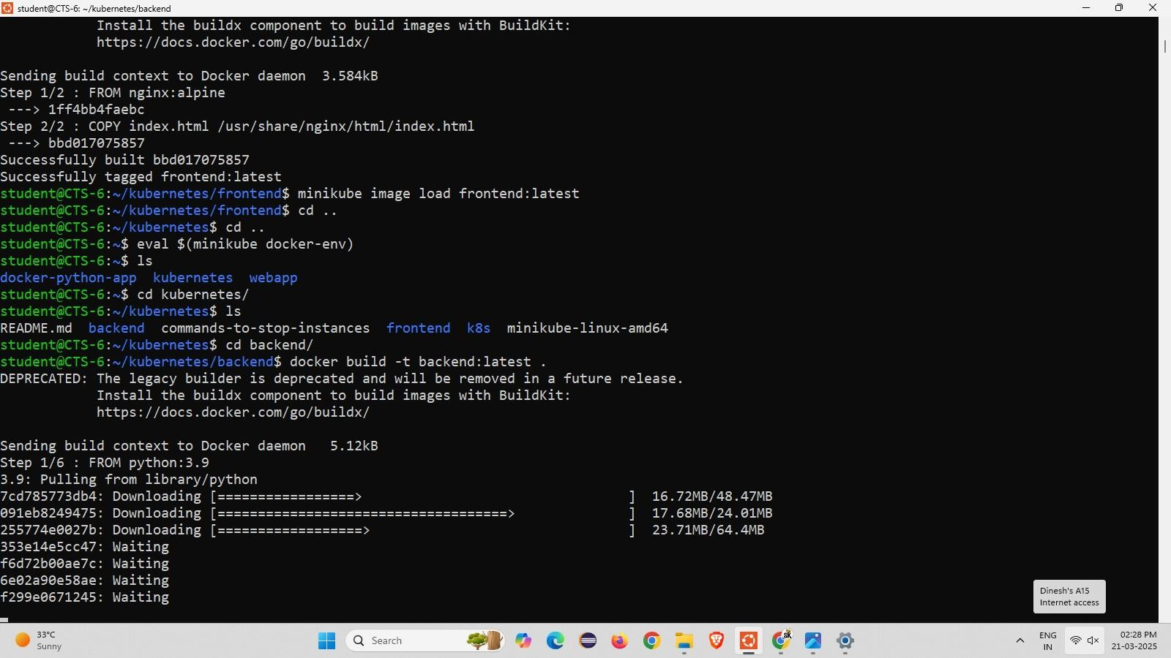

# Step 15 :

Open k8s directory and list the files into it and kubectl apply –f commands and initialize get pods , get svc

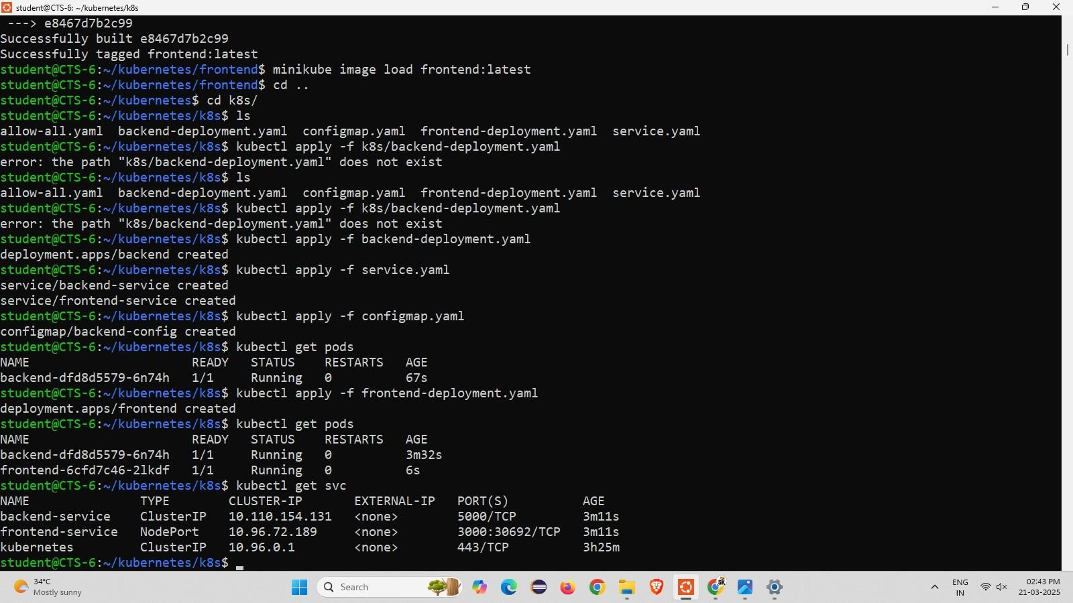

# Step 16 :

using minikube service frontend-service –url it will displays the https:// ip address and using curl command to run in the terminal.

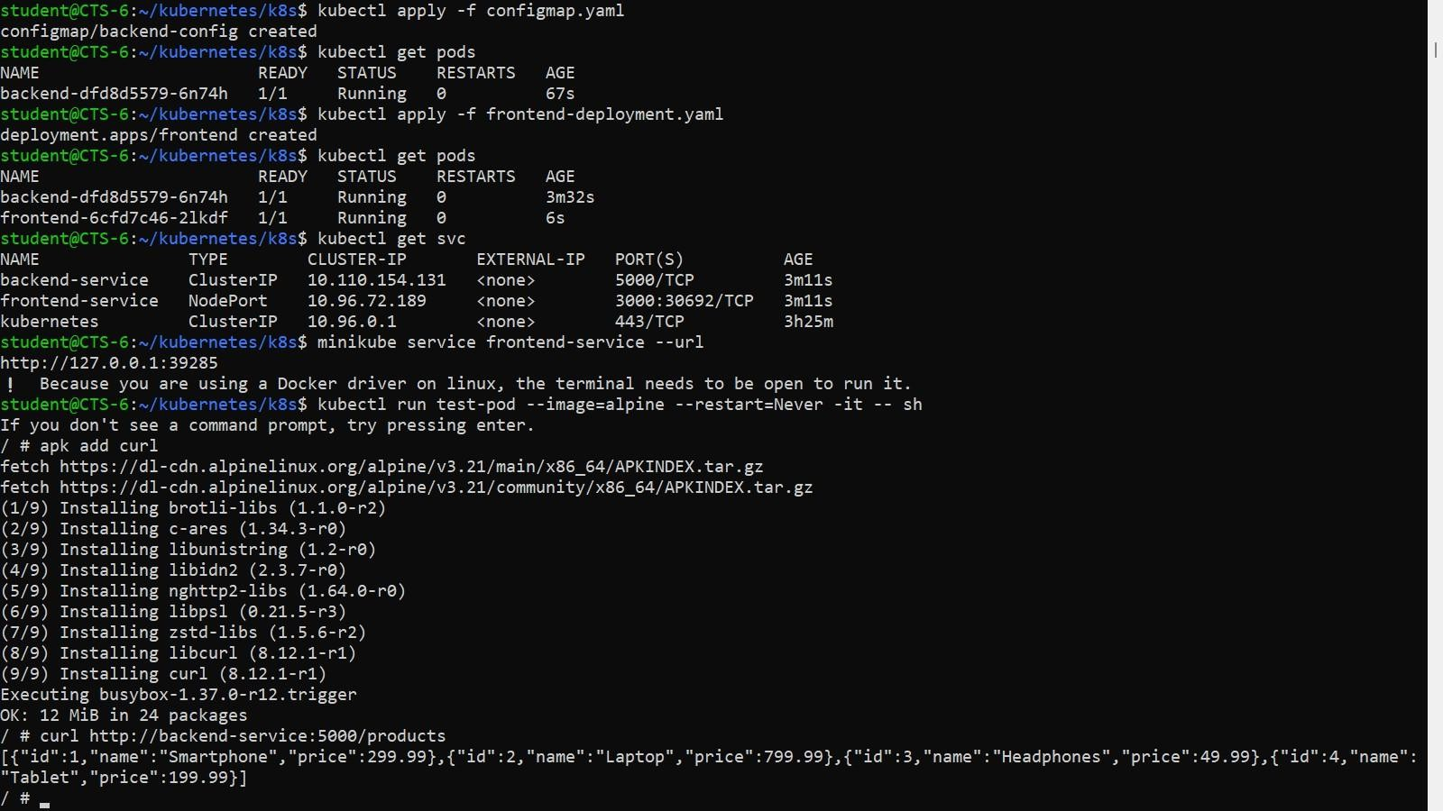

# Step 17:

Enter the given ip address in the browser and get the output.

